BANK LOAN REPORT QUERY DOCUMENT
- BANK LOAN REPORT SUMMARY
KPI’s:
Total Loan Applications
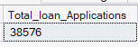
MTD Loan Applications
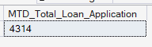
PMTD Loan Applications
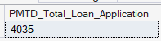

Total Funded Amount
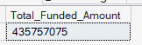
MTD Total Funded Amount
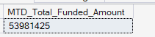
PMTD Total Funded Amount
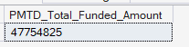
Total Amount received
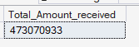
MTD Total Amount received
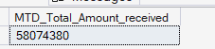
PMTD Total Amount Received
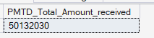
Average Interest Rate
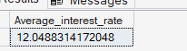
MTD Average Interest Rate
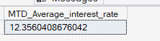
PMTD Average Interest Rate
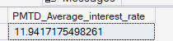

Average DTI
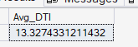
MTD Average DTI
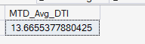
PMTD Average DTI
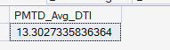
GOOD LOAN ISSUED
Good Loan Percentage
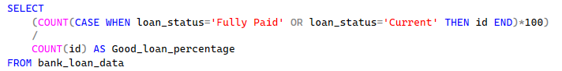
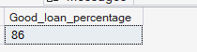
Good Loan Applications
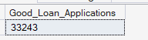
Good Loan Funded Amount
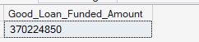
Good Loan Total Received Amount
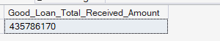
BAD LOAN ISSUED
Bad Loan Percentage
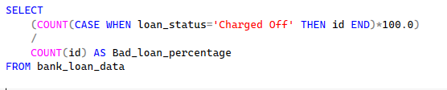
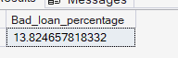
Bad Loan Applications
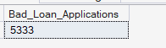
Bad Loan Funded Amount
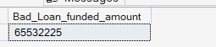
Bad Loan Total Received Amount
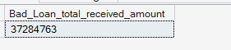

LOAN STATUS
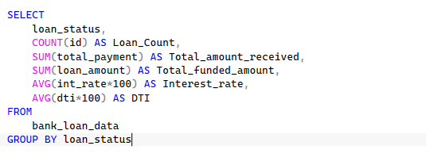
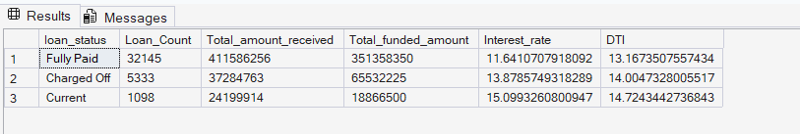
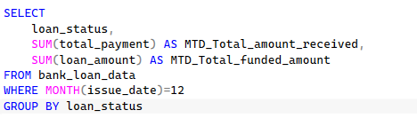
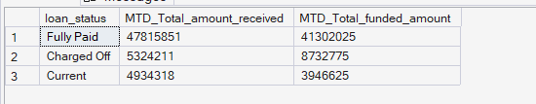

- BANK LOAN REPORT OVERVIEW
MONTH
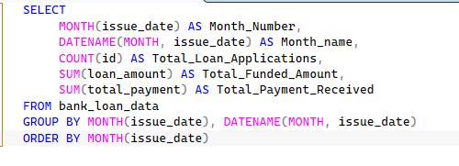
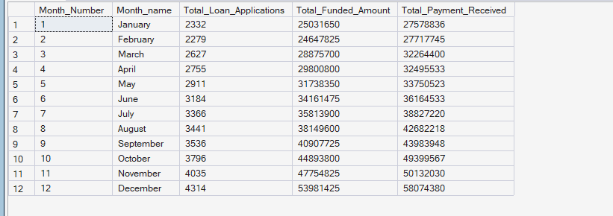

STATE
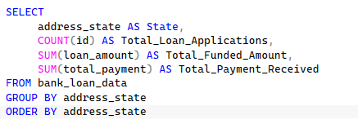
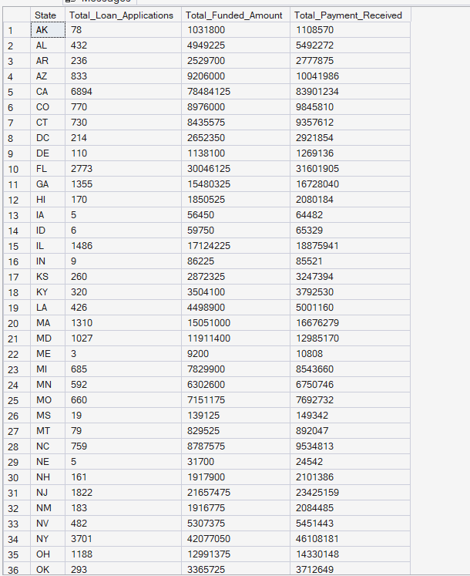

TERM
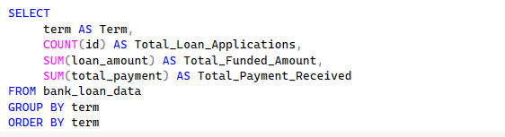
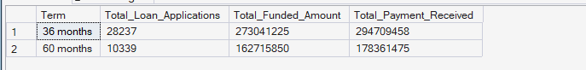

EMPLOYEE LENGTH
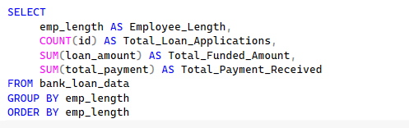
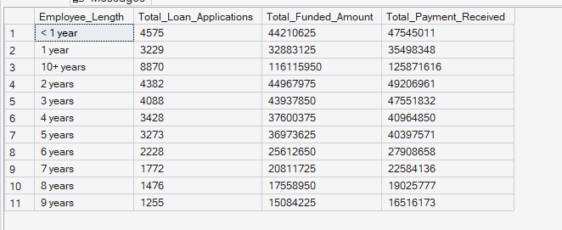

PURPOSE
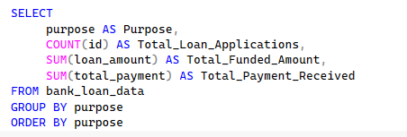
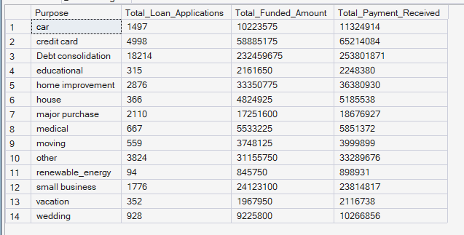

HOME OWNERSHIP
